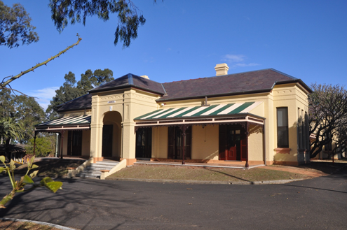

**Linnwood – Listed on the**

**NSW State Heritage Register**



**The Friends of Linnwood invite you to attend an OPEN DAY at**

**LINNWOOD**

**on**

**Sunday 12th March 2023**

***from 11.00am – 3.00pm***

**at**

**25 Byron Road, Guildford**

***$5 Admission***

***(Children under 12yrs admitted free)***



**We do not have the facility at the house or grounds for Debit or Credit Cards**

🙜🙜🙜🙜🙜🙜🙜🙜🙜🙜🙜🙜🙜🙜🙜🙜🙜🙜🙜🙜🙜🙜🙜🙜🙜🙜🙜🙜🙜🙜🙜🙜

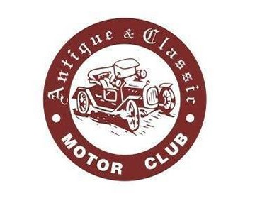





***Refreshments Available:***

**Courtesy of The Friends of Linnwood**

***COME AND SEE……………***

***Community Information Stalls from:***

*“Brislington” Medical & Nursing Museum*

*Justices of the Peace (JP) “Awareness Stand”*

*Old Government House*

***A variety of craft stalls & displays including:***

*Western Sydney Woodturners*

*Chris Lewis Jewellery*

*Gems & Glass Creations*

*Lorraine’s Handbags*

*NSW Spoon Collectors*

*Other stallholders to be confirmed*

As a prelude to our participation in the National Trust’s Australian Heritage Festival in April – with the theme “Shared Stories” – the Friends will be holding an exhibition today telling  stories attached to some of the many donations received by the Friends, or stories of historical interest.

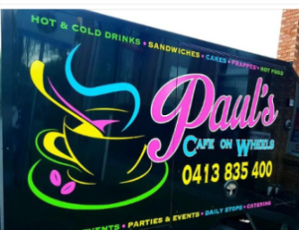

**Coffee cart on the front lawn near the BBQ**



For further information:

Email: [friendsoflinnwood@gmail.com](mailto:friendsoflinnwood@gmail.com)

Website: [www.linnwood.org.au](http://www.linnwood.org.au)

or phone

Dorothy – 0412 606 644

Helen – 0409 227 679

***A small group of vehicles from each of the***

***above car clubs will display on the front lawn***