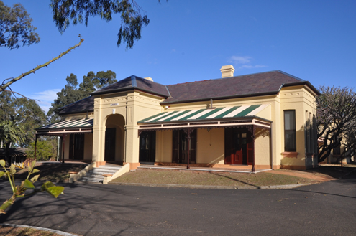
The Friends of Linnwood invite you to attend an OPEN DAY at

LINNWOOD

on
Sunday 8th November 2026
from 10.00am – 3.00pm
25 Byron Road, Guildford

Admission to the house - $5.00
(Children under 12yrs admitted free)
Linnwood – Listed on the
NSW State Heritage Register




Refreshments Available:
Courtesy of The Friends of Linnwood
Eftpos and credit card facilities available.
Cash still accepted.

British Car Clubs
Bentley Car Club
Citroen Classic Owners Club
Daimler/Lanchester Owners Club
Mercedes-Benz Club NSW
MG Restorers Club
Rolls Royce Owners Club
Rover Car Club of Australia
Wolseley Car Club NSW

Exhibitors in red yet to be confirmed
Concours d’Elegance


Logo courtesy of the Club website

And a couple of Great Aussie Battlers!
FB-EK Holden Car Club of NSW
and
FE-FC Holden Car Club of NSW


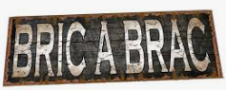

Justices of the Peace will be on site to provide information, advice, or to witness signatures on legal documentation
THE FRIENDS OF LINNWOOD’S

&

All proceeds go towards the upkeep of the gardens
The Duck River Band will be on the front verandah, playing colonial and Irish music

Paul’s Café on Wheels
on the front lawn

STALLS
Inside the House
Australian Lace Guild (NSW)
Hook & Stitch
Mary’s Gifts & Home Décor
Smocking Arts Guild
On the Northern Verandah
Western Sydney Woodturners
In the Grounds
Guildford Probus Plants
Sue’s Transport Books
West Cumberland Mens Shed
For further information:
Email: friendsoflinnwood@gmail.com
Website: www.linnwood.org.au
or phone
Dorothy – 0412 606 644
Helen – 0409 227 679

